**Year 11 General Human Biology**

**Task 2: Supervised written – Cell reproduction, reproductive systems and pregnancy (10%)**

RESULT

/ 37

**Task 2**

**TYPE:** Supervised Written

**CONTENT:** Cell reproduction, reproductive systems and pregnancy

**WEIGHTING:** 10%

**Student Name: MARKING KEY**

**Due date: ___ / ___ / ______**

**Teacher:** Mrs Cunningham

**CONDITIONS:**

Must be completed under test conditions in class. This task will be competed individually.

50 minutes allocated

37 Marks

**TASK DETAILS:**

This task contains **four** questions with a number of parts to assess the student’s understanding of the content from the science understanding topics cell reproduction, reproductive systems and pregnancy.

Notes/reference materials may not be used during this task.

This task contains a number of question types. You could be required to:

* provide single word, sentence or short paragraph responses
* provide responses making connections, drawing conclusions, constructing arguments, analysing and/or evaluating information.

Your responses may incorporate labelled diagrams or tables with explanatory notes.

**Answer all questions in the spaces provided. (TOTAL 37 marks)**

Question 1 (TOTAL 7 marks)

The diagram below shows the structures of deoxyribose nucleic acid (DNA).

1. On the diagram above, write the missing base to complete each base pair. (2 marks)

**T pairs with A (1)**

**C pairs with G (1)**

1. On the diagram above, label the following structures:
2. a sugar molecule **correctly labels a sugar molecule (1)**
3. a phosphate molecule **correctly labels a phosphate molecule (1)**
4. hydrogen bonds. **correctly labels hydrogen bonds (1)**
5. Circle the correct answer to complete the sentences below. (2 marks)
6. The double helix describes the shape of

**DNA    (1)**                          chromosomes

1. The region on a chromosome that contains the code for a trait an organism inherits is a

**gene   (1)**                              mitosis

Question 2 (TOTAL 11 marks)

Cell division plays a critical role in cellular growth, development and reproduction.

The diagram below shows the phases of mitosis, however, they are not in the correct order.

**D**

**C**



**A**

**B**

**E**



1. List the letters A to E in the order that represents the phases of mitosis correctly. (1 mark)

**C E D A B (1 – to get mark must have ALL in correct order) (no half marks)**

Sexual reproduction requires the production of gametes



1. Define the term ‘gamete’. (1 mark)

**A sex / reproductive cell (1)**

Gametes are produced by the process of meiosis. This process produces a cell that is haploid.

1. State what the term ‘haploid’ means. (1 mark)

**A single set of chromosomes (1)**

Human cells contain two sex chromosomes and 22 autosomal chromosomes.

1. Use the information above about humans to complete the following table. (2 marks)

|  |  |
| --- | --- |
|  | Adult female |
| Total number of chromosomes in each body cell | **46 (1)** |
| Total number of chromosomes in each gamete | **23 (1)** |

1. Use the table below to outline three differences between mitosis and meiosis. (6 marks)

**Only one mark is awarded for each difference if a fact about mitosis or meiosis is provided without a complementary difference for the other.**

**To get 2 marks per row – both mitosis and meiosis MUST have a difference written in each box provided.**

|  |  |
| --- | --- |
| **Mitosis** | **Meiosis** |
| **Produces two (daughter) cells** | **Produces four (daughter) cells** |
| **(daughter) cells are identical to parent cell** | **(daughter cells are different to patent cell** |
| **Cells produced are diploid** | **Cells produced are haploid** |
| **Cells produced for growth and repair** | **Produces gametes** |

**Accept other relevant answers**

Question 3 (TOTAL 13 marks)

The diagram below shows the structure of the male reproductive system.

1. Refer to the diagram above to complete the table below. (4 marks)

|  |  |  |
| --- | --- | --- |
| **Label** | **Name of structure** | **Function of structure** |
| **A** | **Bladder (1)** |  |
| **D** | **Prostate Gland (1)** |  |
| **C (1)** | **Vas deferens (1)** | Carries sperm to the urethra |

Both males and females produce follicle stimulating hormone (FSH) and luteinising hormone (LH).

1. Which organ is responsible for the production of these hormones? (1 mark)

**Anterior pituitary gland (can accept pituitary gland) (1)**

1. Identifying the target organ or cells for each of these hormones and state their effect on the male reproductive system. Write your answers in the table below. (4 marks)

|  |  |  |
| --- | --- | --- |
| **Hormone** | **Target organ or cells** | **Effect on male reproductive system** |
| FSH | **targets the seminiferous tubules in the testes (1)** | **stimulates the production of sperm (1)** |
| LH | **targets the interstitial cells of the testes (1)** | **stimulates the production of testosterone (1)** |

Use the key below to answer the following questions (d) and (e).

|  |  |
| --- | --- |
| **2n** | Total genetic material of a human cell |
| **n** | One half to the total genetic material in a human cell |

1. Choose which of the following representation shows correctly what happens to chromosome numbers during the process of fertilisation. (1 mark)

Option one

**n**

**2n**

**2n**

**+ 🡪**

Option two

**n**

**2n**

**2n**

**+ 🡪**

Option three

**n**

**n**

**2n**

**+ 🡪**

Option four

**4n**

**2n**

**2n**

**+ 🡪**

The correct option is:

**Option three / 3 (1)**

1. Justify your choice in question (d). (3 marks)

**haploid number/gametes contain half the total genetic material (n) (1)**

**fertilisation is fusing of two gametes/haploid cells (1)**

**to create a diploid cell/fertilised egg (2n) (1)**

Question 4 (TOTAL 6 marks)

The following diagram is that of a pregnancy at approximately 18 weeks gestation.

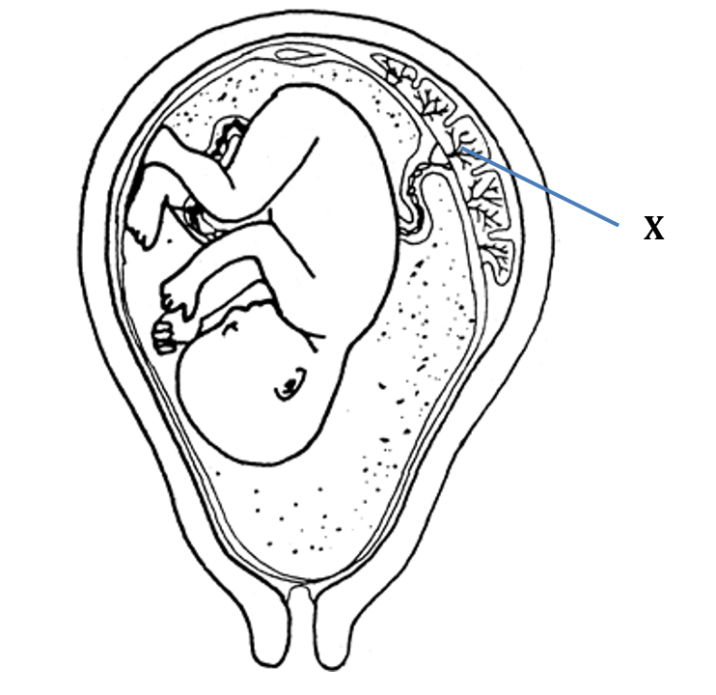

1. Circle the anatomical term that best describes the baby at this stage of gestation. (1 mark)

blastocyst embryo **foetus – (1)**

1. Identify structure X. (1 mark)

**Placenta (1)**

1. Explain how structure X is suited to the function it performs. (4 marks)

**Explains any two features (2 x 2 marks)**

**• large surface area (1) allows for more substances to be exchanged (1)**

**• highly vascular/many capillaries/more blood (1) to bring more requirements and remove wastes (1)**

**• close association between maternal and foetal tissues (1) for rapid exchange of materials (1)**

**Accept other relevant answers**

**END OF ASSESSMENT**